AI Assisted Coding
Lab Assignment 4.5
Name : K.Hemanth Kumar Date : 23/01/2026
Hall Ticket no : 2303A52320 Bt-45

Task -1:
Prompt: Write a Python function that takes a year as input and checks whether it is a leap year. Return True if it is a leap year, otherwise return False

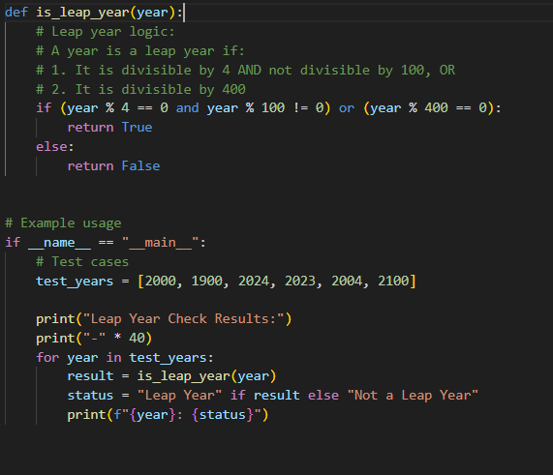
Output :
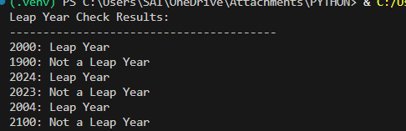

Task 2:
Prompt: generate a python program that classify travel queries into flight booking, hotel booking, cancellation, and general travel information. The program should create labeled travel queries, apply all three prompting techniques .

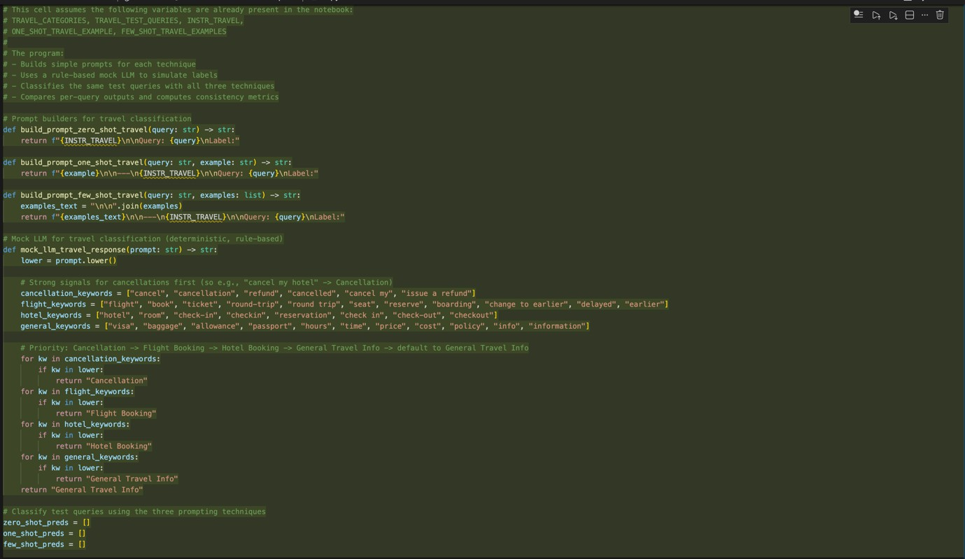
Output:

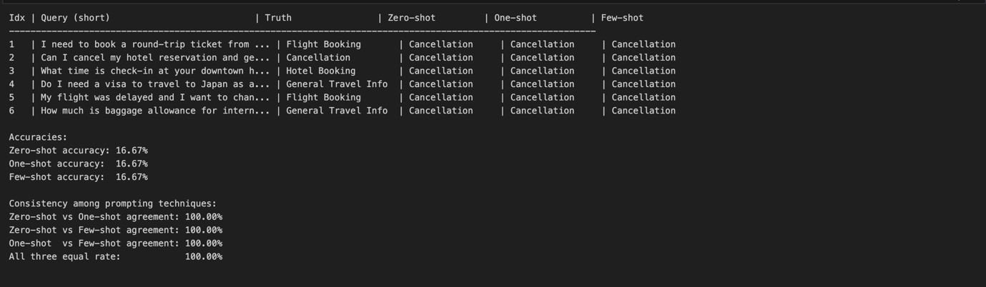

Task 3:
Prompt : generate a python code to help chatbot must classify queries into syntax error, logic error, optimisation . The program should also include coding- related user queries,Perform zero-shot , one-shot , few-shot classification and Analyse improvements in technical accuracy.

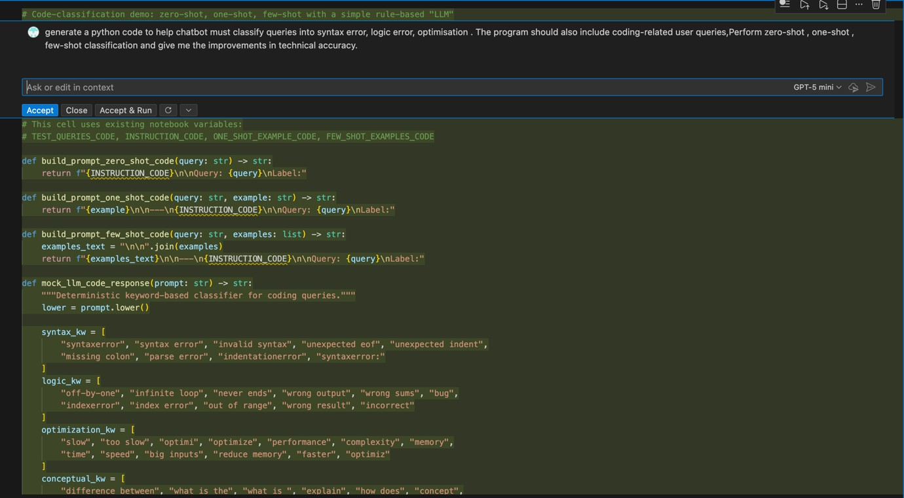
Output :

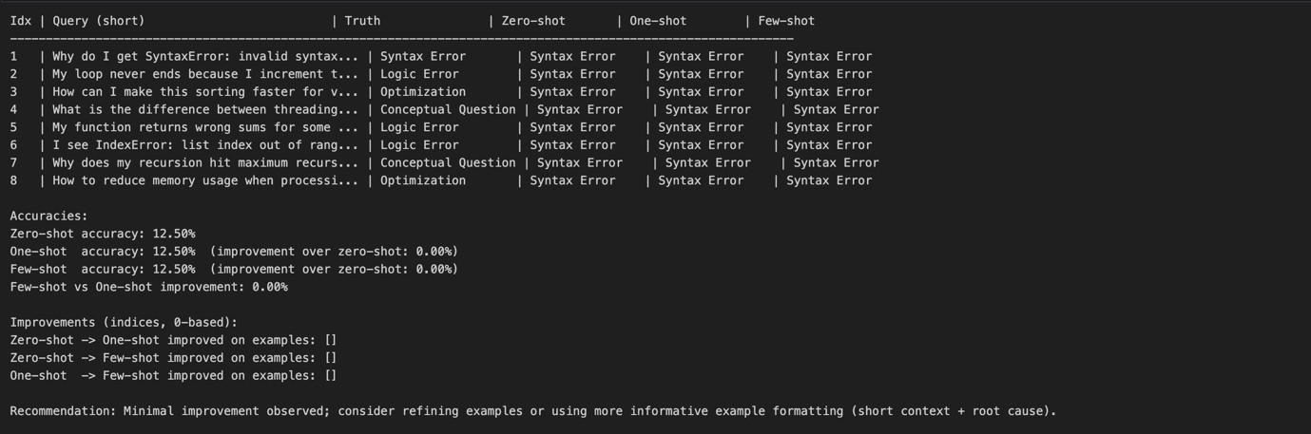

Task 4 :
Prompt : generate a python program to classify social media posts into Promotion, Complaint, Appreciation, or Inquiry using zero-shot, one-shot, and few-shot prompting, and compare informal language handling.

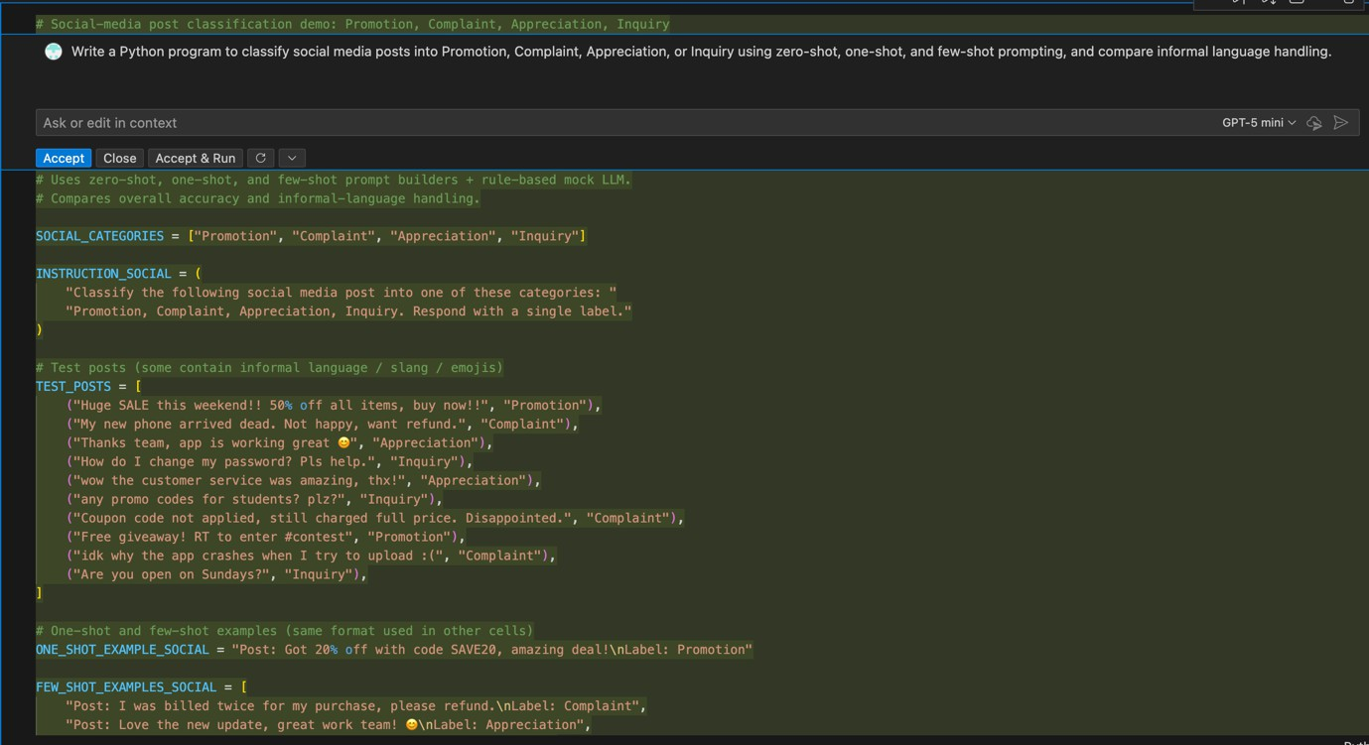

Output :
